gRPC (gRPC Remote Procedure Call) is a high-performance, open-source framework developed by Google. It uses Protocol Buffers (Protobuf) for serialization and enables client-server communication through remote procedure calls (RPCs). gRPC supports multiple programming languages and is built on top of HTTP/2, offering features like multiplexing, bidirectional streaming, and efficient binary data transmission.

Key Components of gRPC
- Protocol Buffers (Protobuf):
  - A language-neutral, platform-neutral serialization format.
  - Defines the data structure (message) and services (methods) used for communication.
- gRPC Service:
  - A service is defined in a .proto file, containing the methods (RPCs) and their input/output message types.
- Stub:
  - A client-side representation of the service that provides access to RPC methods.
- Server:
  - Implements the gRPC service defined in the .proto file.
- Channel:
  - A client establishes a channel to the server for communication.
- Streams:
  - gRPC supports different types of communication:
    - Unary (single request/response).
    - Server streaming.
    - Client streaming.
    - Bidirectional streaming.

gRPC Workflow Steps
- Define the Service:
  - Use a .proto file to define the service and its RPC methods.
  - Example:
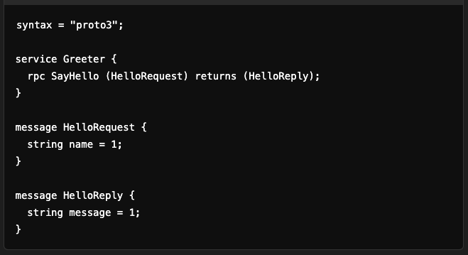
- Generate Code:
  - Use the Protobuf compiler (protoc) to generate client and server code in the desired programming language.
  - Example command:


- Implement the Service:
  - On the server side, implement the service methods defined in the .proto file.
  - Example (Java):
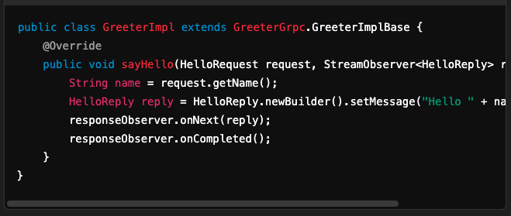
- Run the Server:
  - Start the gRPC server to listen for client requests.
  - Example:
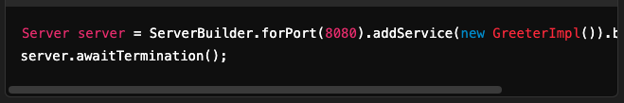
- Create the Client:
  - Use the generated stub to create a client that invokes the RPC methods.
  - Example (Java):
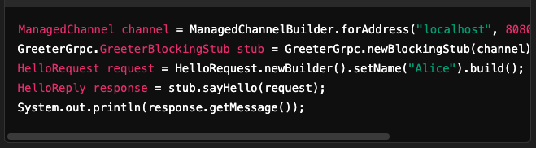
- Communication:
  - The client sends a request to the server using the stub.
  - The server processes the request, generates a response, and sends it back to the client.

gRPC Communication Types
- Unary RPC:
  - A single request from the client and a single response from the server.
  - Example:
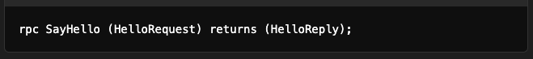
- Server-Streaming RPC:
  - The client sends a single request, and the server sends a stream of responses.
  - Example:
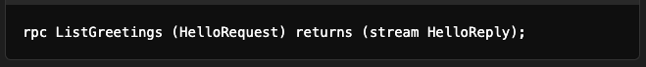
- Client-Streaming RPC:
  - The client sends a stream of requests, and the server sends a single response.
  - Example:
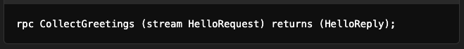
- Bidirectional Streaming RPC:
  - Both the client and server send streams of requests and responses simultaneously.
  - Example:
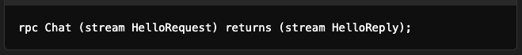

gRPC Flow Diagram
- Unary RPC:
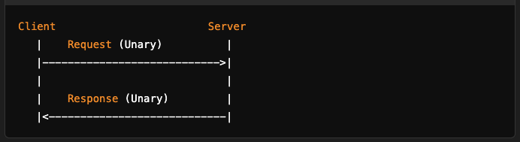
- Server-Streaming RPC:
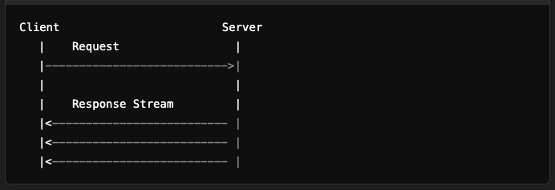
- Client-Streaming RPC:
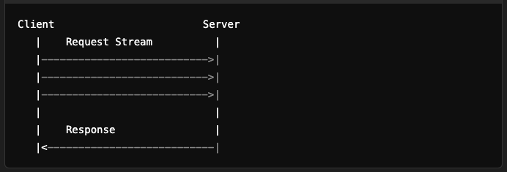
- Bidirectional Streaming RPC:
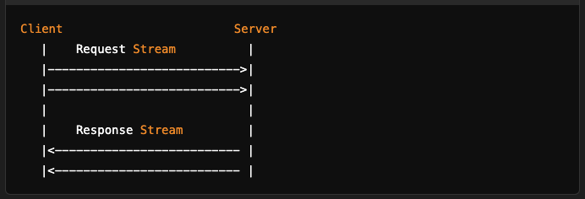

Advantages of gRPC
- High Performance:
  - Based on HTTP/2, enabling features like multiplexing and efficient binary serialization.
- Cross-Language Support:
  - Works seamlessly across multiple programming languages.
- Streamlined Communication:
  - Supports streaming for real-time and high-throughput applications.
- Compact Data:
  - Protobuf reduces the size of payloads compared to JSON or XML.
- Built-in Code Generation:
  - Automatically generates boilerplate code for client and server.

Challenges
- Complexity:
  - Requires learning Protobuf and setting up the gRPC environment.
- Limited Browser Support:
  - Native gRPC over HTTP/2 is not directly supported in browsers; gRPC-Web is needed.
- Debugging and Logging:
  - Binary data and streams are harder to debug compared to plain-text protocols like REST.

Use Cases
- Microservices Communication:
  - Efficient communication between distributed services.
- Real-Time Applications:
  - Streaming data, such as chat systems or IoT devices.
- Data-Intensive Applications:
  - Applications requiring low latency and high throughput.
- Cross-Language Integration:
  - Communication between services written in different programming languages.

